**Practice Work – 4 (Normalization)**

Due Date: October 13, 2015, 10PM

**1.** Consider the following relation.

DiskDrive (serialNumber, manufacturer, model, batch, capacity, retailer).

Each tuple in the relation DiskDrive contains information about a disk drive with a unique serialNumber, made by a manufacturer, with a particular model, released in a certain batch, which has a certain storage capacity, and is sold by a certain retailer.

For example, the tuple DiskDrive (1978619, WesternDigital, A2235X, 765234, 500, CompUSA) specifies that WesternDigital made a disk drive with serial number 1978619, model number A2235X in batch 765235 with 500GB that is sold by CompUSA.

Write each of the following dependencies as an FD:

a. The manufacturer and serial number uniquely identifies the drive

b. A model number is registered by a manufacturer and hence can’t be used by another manufacturer.

c. All disk drives in a particular batch are the same model.

d. All disk drives of a particular model of a particular manufacturer have exactly the same capacity.

(20 points)

SOLUTION:

a. manufacturer, serialNumber model, batch, capacity, retailer

b. model manufacturer

c. manufacturer, batch model

d. model capacity

**2.** Consider the following relations for an order-processing application database at ABC, Inc.

ORDER (O#, Odate, Cust#, Total_amount)

ORDER-ITEM (O#, I#, Qty_ordered, Total_price, Discount%)

Assume that each item has a different discount. The Total_price refers to one item, Odate is the date on which the order was placed, and the Total_amount is the amount of the order.

Are the relations in 3NF? If not, normalize them to 3NF.

(20 points)

SOLUTION:

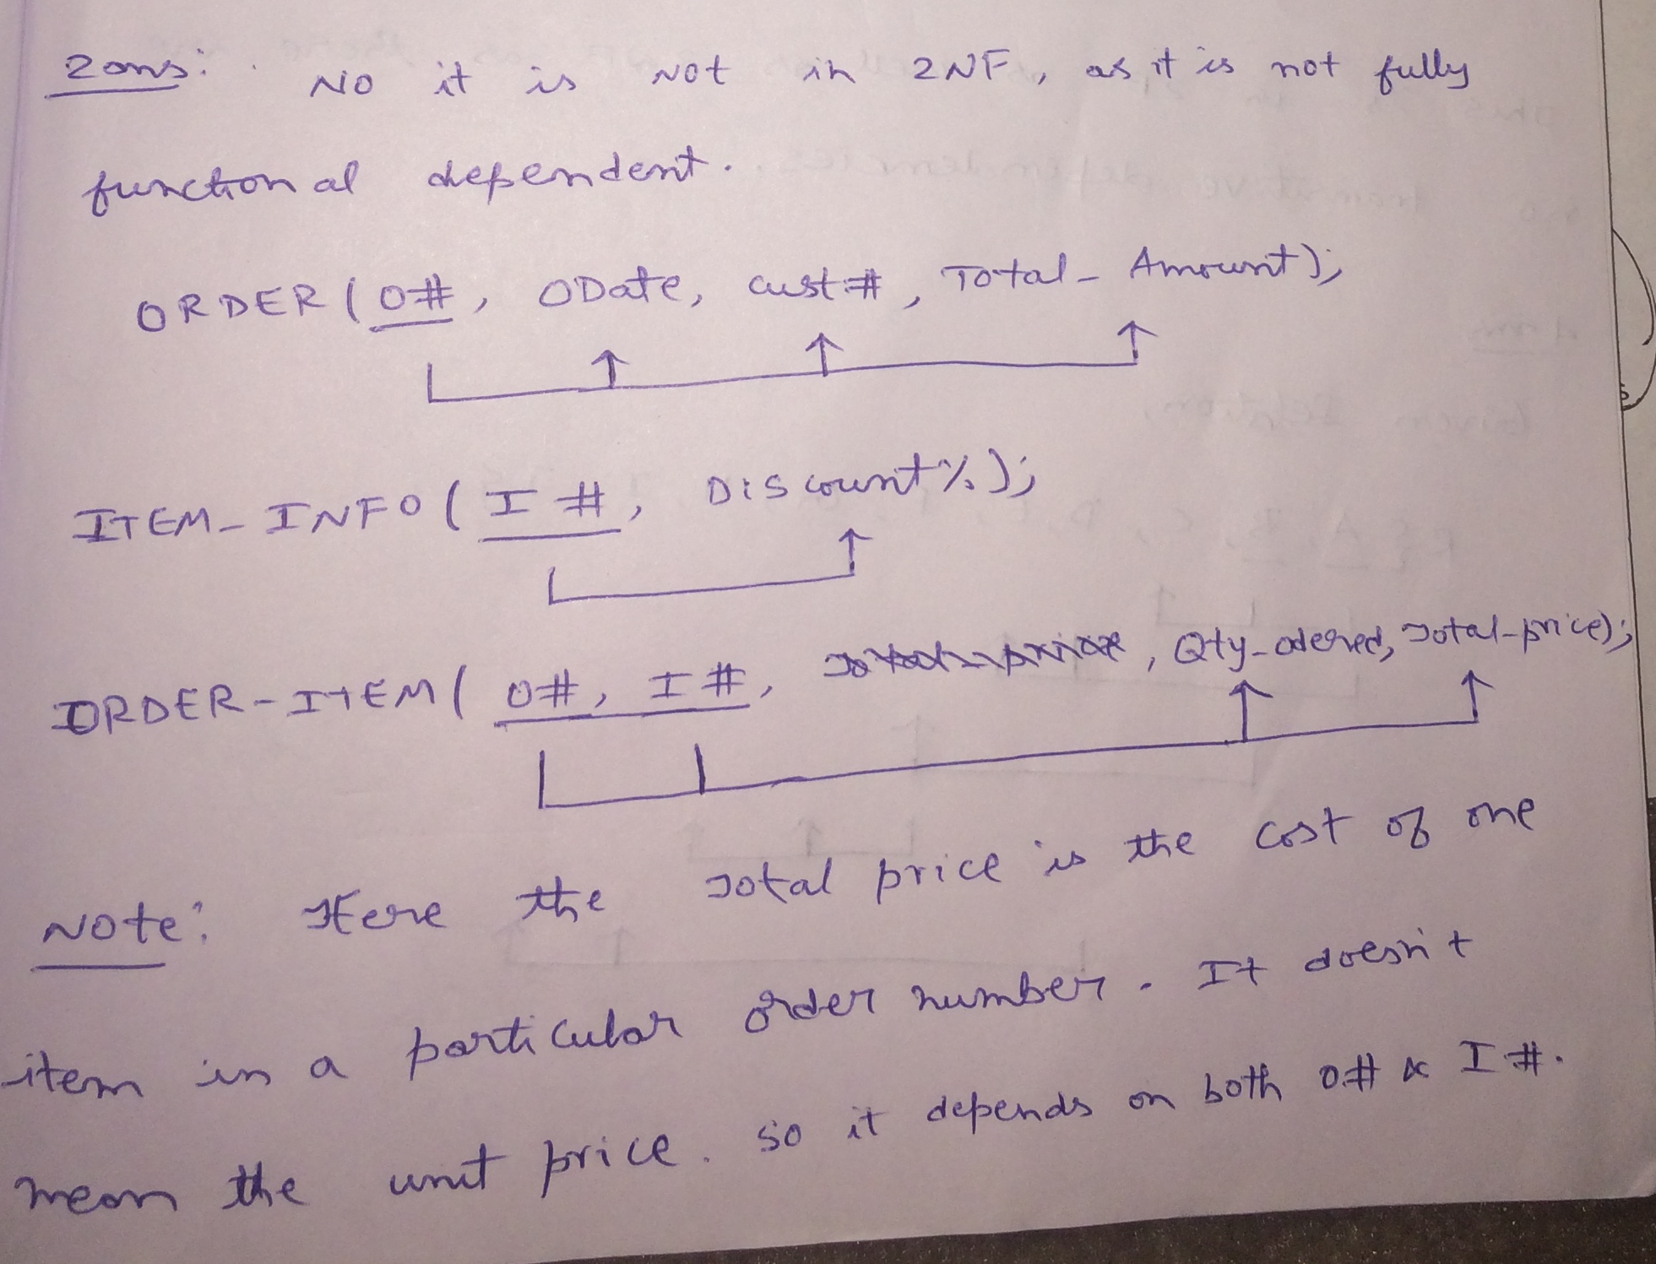

Since now there are no transitive dependencies it is in 3 NF also.

**3.** Consider the following relation.

CAR_SALE (CarID, Option_type, Option_Listprice, Sale_date, Discounted_price)

This relation refers to options installed on cars (e.g.- cruise control) that were sold at a dealership and the list and discounted prices for the options.

Based on following functional dependencies, is the relation in 3NF?

If not, normalize it to 3NF.

CarID → Sale_date

Option_type→ Option_Listprice, and

CarID, Option_type → Discounted_price (20 points)

SOLUTION:

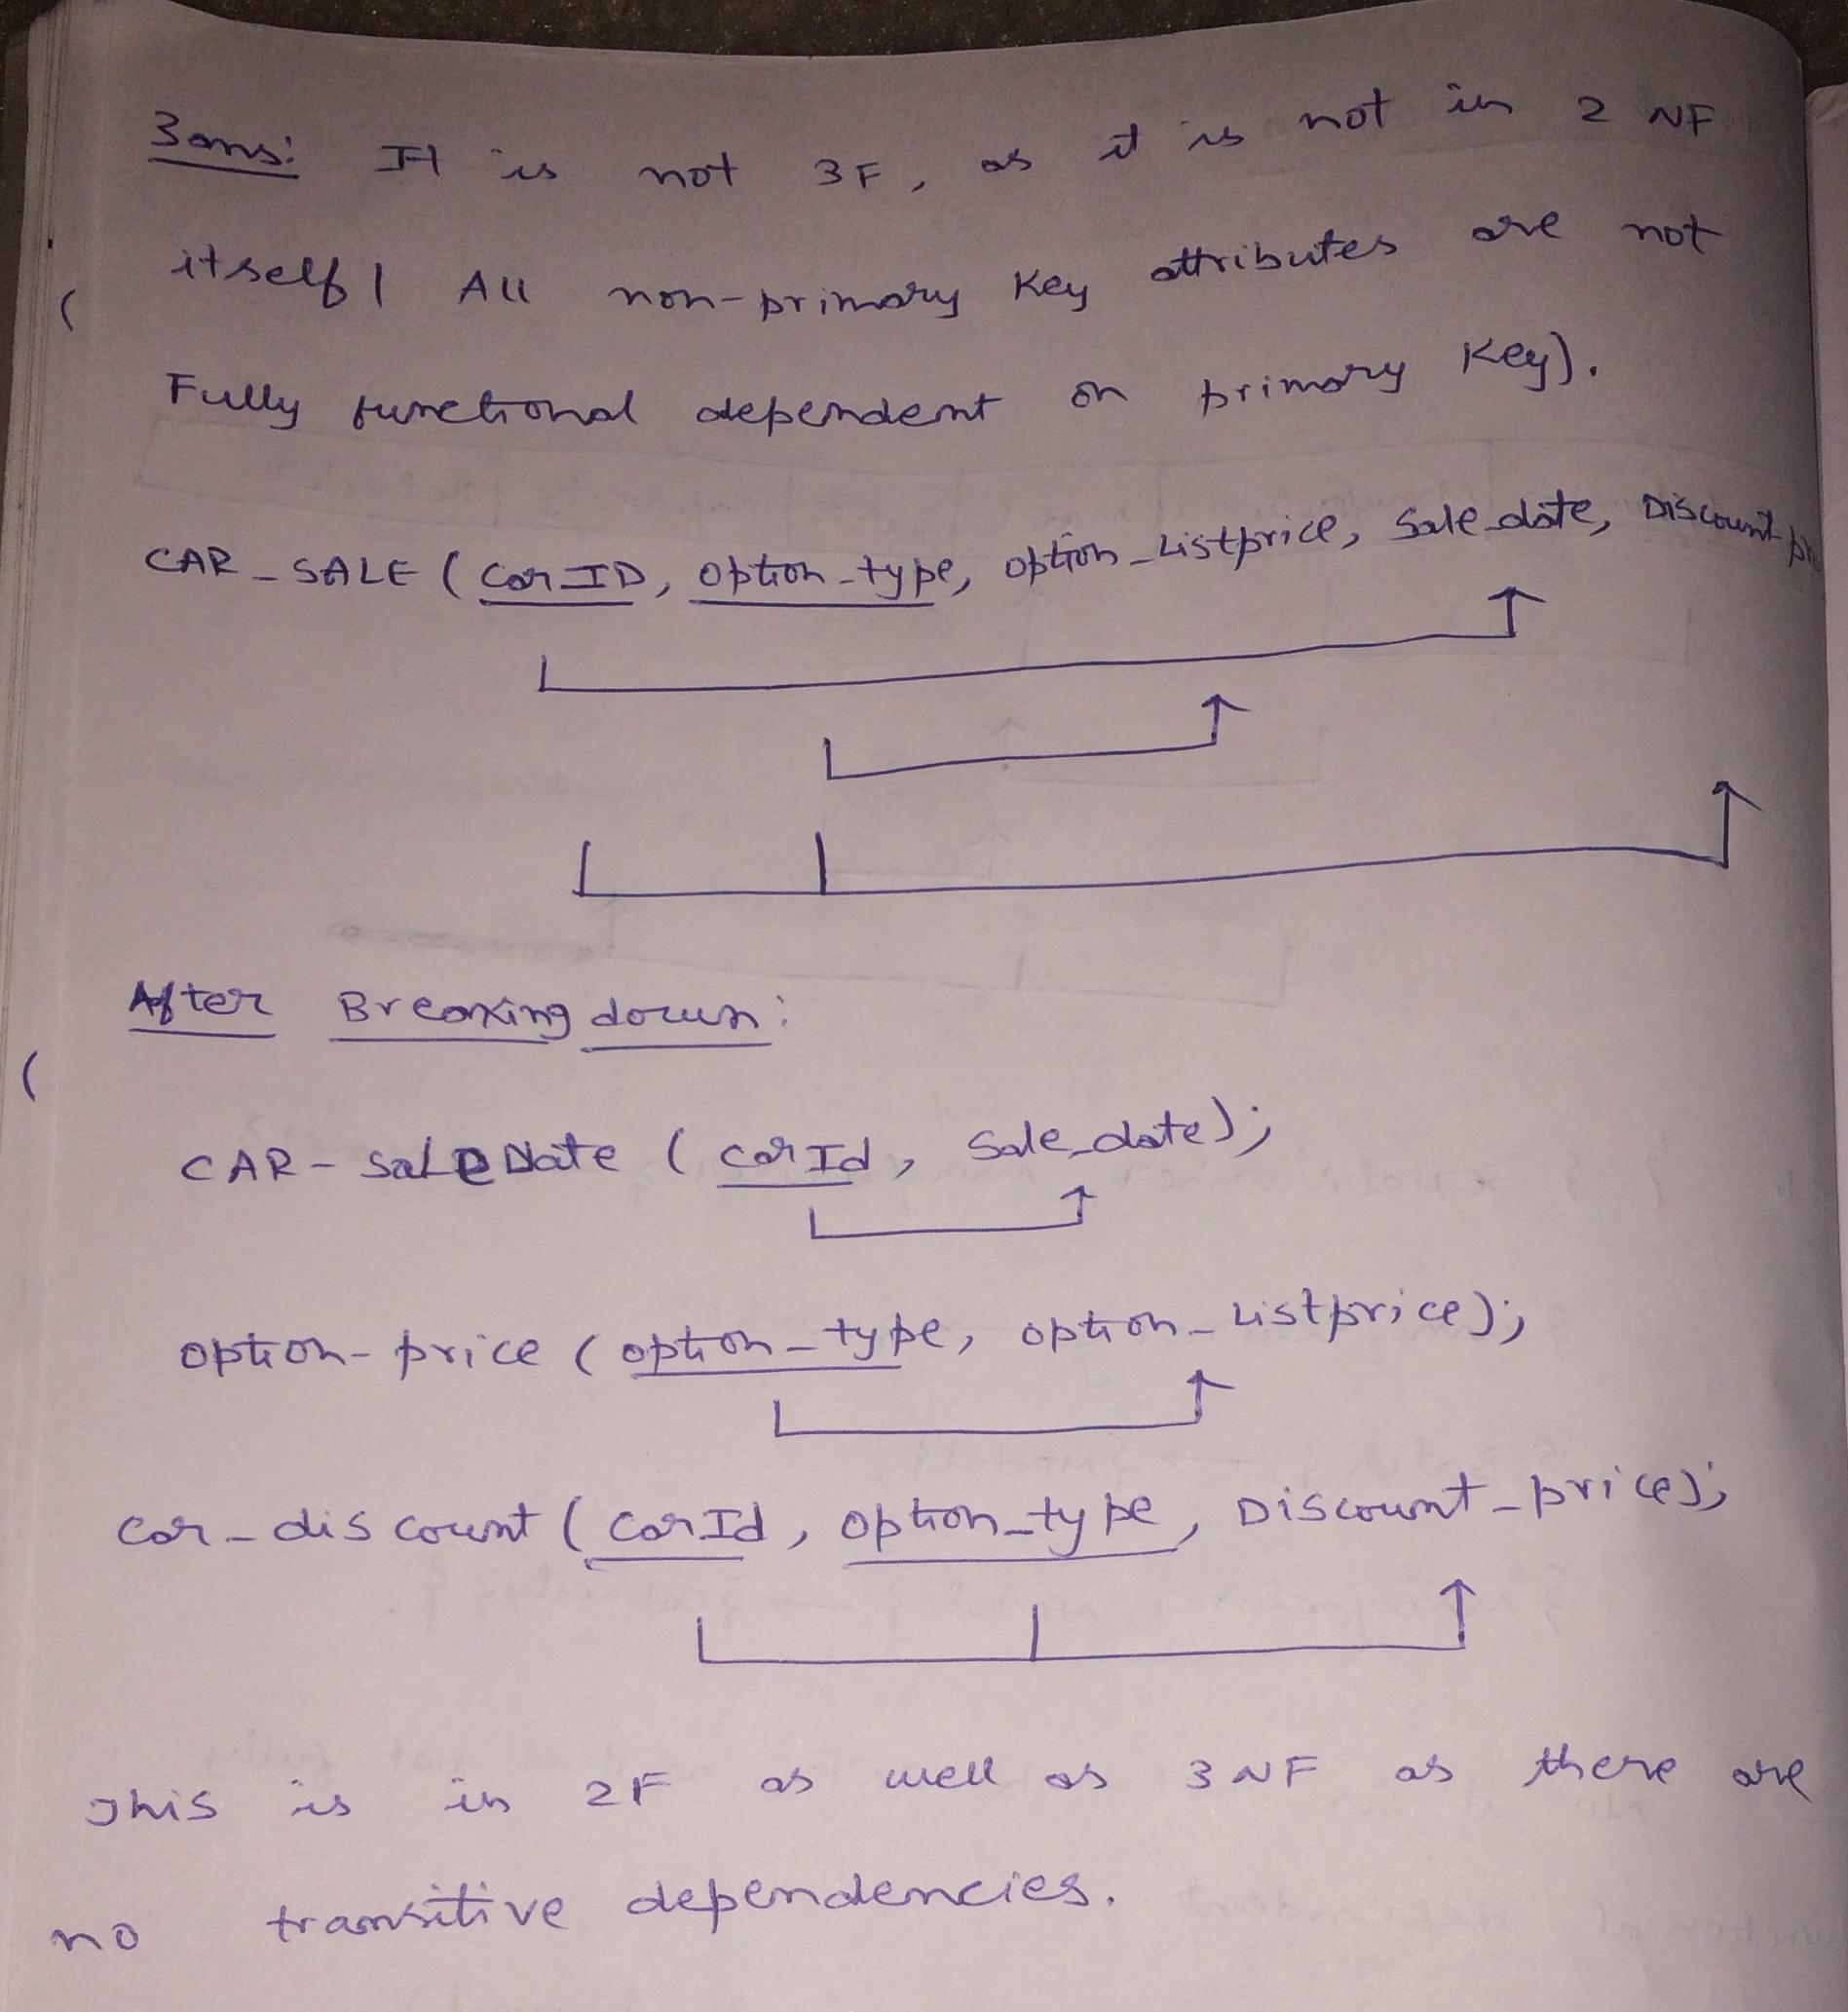

**4.** Consider the universal relation R = {A, B, C, D, E, F, G, H, I} and the set of functional dependencies F = { {A, B} -> {C}, {A} -> {D, E}, {B} -> {F},

{F} ->{G, H}, {D} -> {I, J}}.

Decompose R into 2NF, then 3NF relations.

(40 points)

SOLUTION:

